|  |  |
| --- | --- |
|  | Vision & Scope Document |
| 5/7/2013 | Graduate Capstone |

Table of Contents

1 Introduction 2

1.1 Revision History 2

2 Project Background 3

2.1 So where does this competitive edge lie? 3

2.2 Where Does the Data Come From? 3

2.3 Transactions 3

3 The Problem 4

3.1 So When Should I Take the Survey? 5

4 Vision Statement 5

5 Stakeholders 6

6 Users 6

6.1 User 6

6.2 Administrator 6

6.3 Company 6

6.4 Diagram 7

7 Main Features 8

7.1 Convenience 8

7.2 Security 9

7.3 Language 9

7.4 Monetization 10

8 Features Not Developed 10

# 1 Introduction

The purpose of this document is to identify the vision of the software application and the business applicability it has.

## 1.1 Revision History

|  |  |  |  |
| --- | --- | --- | --- |
| Name | Date | Reason For Change | Version |
| Andy Bottom | 02/16/2013 | Implemented most of the entire document | 1.0 |
| Andy Bottom | 04/28/2013 | Reformatted the document to be consistent throughout. | 1.1 |

# 2 Project Background

In America, we are a fundamentally corporate world. The open marketplace where businesses compete for the business of the consumer and fight to get the edge over their competitors. Of course the goal in business is to make money. That is where the importance is on the customer. The customer equals revenue for your company and many corporations understand the fact that having a loyal customer is the best thing to have.

## **2.1 So where does this competitive edge lie**?

Many believe that investment in knowing who your customer is and catering to their needs has enormous positive effect. That is why there has been a huge push towards spending money on analytics. By understanding the customer, the company knows exactly what the consumer wants and how they can appeal to them to reach the end goal of gaining a loyal customer and a returning source of revenue.

## 2.2 Where Does the Data Come From?

This is in fact the solution we are coming towards. At some point the end user needs be surveyed in order to attain the information and perform analytics which the business can thus turn into statistics and make appropriate adjustments.

If you scroll through the internet, you often can find all sorts of sites that want a user to fill some questions to then. But this doesn’t necessarily target the people that get to the people who are in the stores making purchases. This is why there uses a different outlet for transactions.

## 2.3 Transactions

Transactions are what are involved with any purchase. A customer purchases a product from a company, and pays a certain amount of money for it. This transaction then creates a receipt for the customer to hang on to for proof of purchase. Since the transaction is the goal for the business, and the overall strive to reach the customer is growing, it has become a very common practice to use the receipt as an opportunity to be able to acquire the data directly from a consumer who is already making a purchase.

However, most customers will never willing take their valuable time to fill out a survey for a company because there isn’t anything in it for them. This is why corporations will offer an incentive for the customer to fill out their survey. By filling out a survey the company will receive the valuable data to form analytics, and the customer will receive a little reward for taking the time to submit it.

The rewards can range to a variety of things, but most will fall into two categories, a contest where a customer will be entered into a raffle for a very valuable prize for a chance to win it. The other is a very small prize that they will attain. For instance, a coupon for $2 off of something or even maybe a free item, such as a cookie from a restraint. The small prizes are 100% which is why the business needs to take into account how much the small amount prize is verses the revenue gained from the data.

# 3 The Problem

The problem arises in the actual follow through of the receipt surveys. Traditionally the way it works is that the customer makes a purchase and gets the receipt and the request to fill out the survey. The survey requires going to their website to send the information. The user arrives home and takes the receipt, goes to the computer and takes the survey and redeems the reward. They then save the receipt and the code till the next time they go to the business and can then redeem their reward.

The problem occurs because this is not how it actually works. People tend to lose their receipts because most of them aren’t very valuable or worth hanging on to. Also, by the time that the get home, the time has passed of which the importance of the receipt is not worth the trouble, (aka procrastinate.) Because of this, the task become cumbersome the further away it gets that it is unlikely that it will ever get done.

## 3.1 So When Should I Take the Survey?

The best time to actually fill out the survey is when you have the receipt right in front of you when you finish the transaction. Thanks to the availability of the internet through the rise of smart phones and tablets, it has become very easy and almost convenient to take the survey while you are out and about. You can easily fill out the survey by going to the website. Unfortunately, most of these survey websites do not cater to the mobile phones.

This situation thus is a lose-lose for everyone. The customer has to go through all sort of obstacles to get the reward, and thus don’t take the time. Because of this, the businesses lose out on very beneficial analytical data. This is the overall problem of this capstone that we will hope to solve and change to a win-win for everybody.

# 4 Vision Statement

Our solution is geared to make the receipt surveys into a win-win situation for everyone. We have researched and found that the people are most likely to fill out the survey is when they have the receipt in hand.

Since mobile smart phones have been growing dramatically in popularity and the ability to have content instantly at hand through applications is become a very large resource. This is how we intend to address the surveys.

Our goal is to create a smart phone application that will allow users to easily choose their survey and be able to have a easy to fill out interface to complete surveys and track their rewards, all in one convenient place. I have researched and found that many of the survey website are not mobile friendly, which makes it harder to use.

# 5 Stakeholders

Andy Bottom is the only person working on this project thus he is the only stakeholder in this project. However in the future, this product may be used to help small businesses gather analytics, in which the small businesses would become stakeholders in the successfulness of the project.

# 6 Users

The basic description of how the system works is the following. The companies use the application to reach and obtain data and information from the users. The administrator ensures that the surveys and data of the application are functioning properly. The users use the application to send data to the companies in order to retrieve an award.

## 6.1 User

The user is the person who will be interacting with the system and features through the phone. They are who the phone application was made for to interact.

## 6.2 Administrator

The administrator user is person who is managing the data, specifically the surveys and companies and users to keep the surveys functioning properly.

## 6.3 Company

The company user is who custom surveys will be created for and who gets sent the data and reports from their survey every month. The company can be both the company’s survey websites, and a custom survey implemented through our product.

## 6.4 Diagram

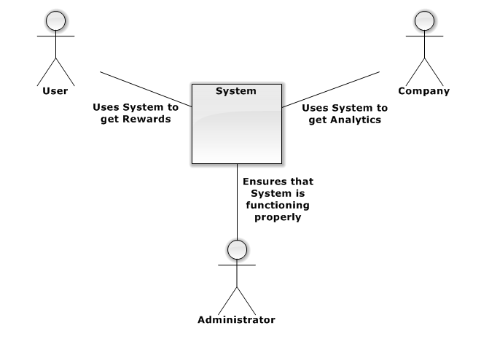

# 7 Main Features

Below is a high level list of functionality that explains the functions of the application that would be beneficial to the project from a business point of view and are key to the success.

## 7.1 Convenience

This is the number one goal of the project which will make people want ot use it, because it will be so much more convenient that people would have to be “dumb” to not use the app. The following ways we will do this is by.

* Easy to use interface for the mobile phones. The surveys will be outputted to the user in a nice and mobile-phone friendly view.
* When a person is logged in as a user, then we will store key information that are common answers on many surveys (such as gender) and the those questions won’t be displayed to the user because we already know the answer, thus providing convenience.
* Users who by the premium feature of automatic completion will either do one of the following convenient features
  + The user will be able to run the survey and the previous answers will be submitted for that location if they say that nothing has changed.
  + The user will step through each section and determine if anything changed from that previous location
  + A user can choose to use the same answers from a different location that were similar.
* Also, the fact that they can fill out surveys for receipts to many of their favorite companies is another major feature the user will like and very convenient.

## 7.2 Security

Security is also another important aspect of the application

* People will not have to have a user account with our system, (they can do the very basic stuff that you can normally do through the website.) So anonymous users will be able to fill out the surveys
  + When an anonymous user is waiting for their reward, the waiting page will show the user the following message: We noticed that you are not a user yet, become a user and have access to many of these great features to make your survey next time even quicker. And it’s Free”
* For surveys that send a coupon to the user’s e-mail address, then we won’t submit the user’s e-mail, but instead have the coupon be sent to the receipt reward address and the coupon will be pulled from their and sent to the user.
* Security will be taken into account for the web services to secure any sensitive data that may be sent.

## 7.3 Language

* The phone will support the ability to display in many languages (probably whatever the top 10 largest languages.) This will have the competitive edge over the actual surveys that typically at most only support 1 - 3 languages. This also adds convenience.

## 7.4 Monetization

* Work with small businesses to set them up with their own custom survey in which people will use my app to fill them out. I will charge them a very low monthly fee to send them a monthly report including the analytics that they can use to improve.
* The first couple months, I will offer a free trial for the business, in exchange for having a display regarding the app for users to take their surveys. That way it will help publicize my application to get gain users.
* I will have the premium feature of automated surveys. Since this is a premium version, users will have to purchase the feature via an in-app purchase.
* Worst-case scenario, I could just have an advertising box and make a couple pennies.

# 8 Features Not Developed

The following is a list of the features that will not be developed for the scope of my Capstone. They will be implemented at a later time, but due to the time constraint of this class, cannot be developed in time.

* Only the Windows Phone and basic functionality of another Phone OS will be implemented.
* All CRON jobs that would run daily checks and tests will not be implemented
* All functionality involving creating custom functionality for Small-Business will not be implemented.
* High level security precautions may not be implemented.
* User maintenance in the Admin CMS will not be implemented.
* Only a couple reward obtaining actions of the Web Driver will be implemented.
* Any monetization functionality will not be created.
* Premium Automatic Survey Submissions for the User will not be implemented
* Use of anonymous e-mail and phone submissions will not be implemented.